The business manufactures composite panels comprising a sandwich of a “security cassette” and core material between 2 steel faces. All elements are bonded together using a 2 part adhesive.
The security cassette comprises a cut-resistant galvanized steel/plywood sandwich bonded with a hot melt adhesive.
There are three main production lines supported by three off-line processes.
Off-line – “cassette prep”
- Core pre-former.
- Galvanized steel guillotine.
- Plywood saw.
Production lines
- Line 1 – manufacture of security cassette.
- Line 2 – manufacture of panel.
- Line 3 – “Custom Clad” – CNC cut outs (not operational at time of application).
The three off-line process prepare raw materials for the production line. The processes are shown below.
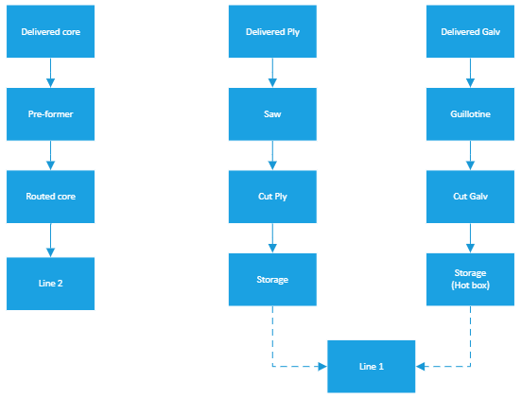

Line 1 is a laminating process that manufactures the security cassette. The process is shown below.
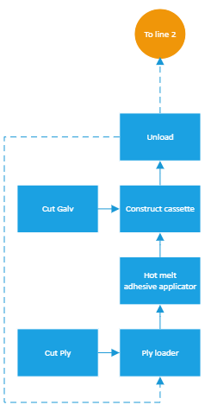

Briefly, the cassette is created by bonding the pre-cut ply and pre-cut galv using a hot melt adhesive (<5% di-isocyanates). The completed cassette is employed in the finished panel manufacturing on line 2. The cassette is passed back through the process for higher rated panels to add further ply and galv.
Line 2 manufactures the security panels. The process is shown in process flow 6.
Sheet steel is de-coiled, cut to the required length and preformed:-
- the bottom face passes along the line to the adhesive station;
- the top face is diverted to the rear of the adhesive station;
- the cassette manufactured on line 1 is loaded onto the line and transferred to the adhesive station when required;
- core material is manually loaded at the adhesive station as required.
The manufacturing process involves building up the product from the bottom face with adhesive applied prior to adding the next element.
Once construction is complete, the panel passes into the press where pressure is applied whilst the adhesive cures.
Once released from the press, the panel is cut to size if necessary and then either passes to line 3 for cut outs or directly to wrapping and dispatch.
Process flow 6 – line 2.
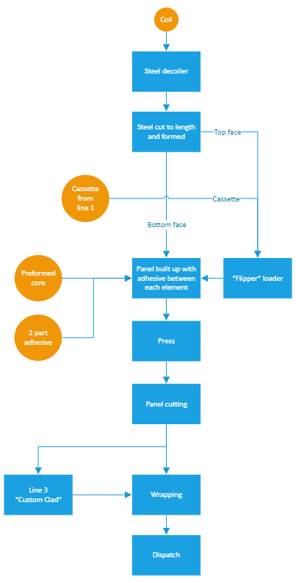

Potential VOC emissions from:-
- handling and use of solvent-based cleaning materials such as AC90;
- handling and storage of waste solvents and solvent contaminated waste.

Potential di-isocyanate emissions from:-
- the hot melt glue employed on line 1 contains low levels (<5% w/w) of
4,4'-methylenediphenyl diisocyanate;
- the line 2 process employs a 2 part adhesive. One component contains diphenylmethane-diisocyanate, isomers and homologues;
- handling and storage of waste adhesive and adhesive contaminated materials.

Line 2 adhesive components are supplied in 1000l IBCs. The hot melt adhesive is supplied in a 200kg metal drum. There is no bulk storage of either item on site. Blowing agents are incorporated within the polyol formulation component. There is no handling or mixing of blowing agents on site.

The line 2 adhesive process sees the 2 components mixed and applied from a multi bead XYZ head. There is no generation of airborne aerosol/mist emissions.

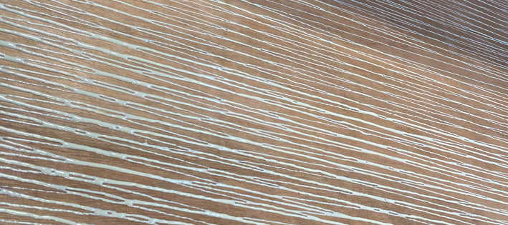
All raw materials are stored inside the building where possible. An area at the rear of site
can be employed as an overflow. Adhesives are always stored inside.
Potential particulate emissions from cutting activities:-
- core material (PIR and Rockwool) profiler;
- plywood beam saw;
- line 2 panel saw (not installed at time of application);
- line 3 CNC (not operational at time of application);
- handling and storage of waste materials from above collected in local LEV systems (core profiler and plywood beam saw) or external LEV (others).

No cutting activities involve hot wires.
The core profiler and plywood beam saw (shown below) have their own dust extraction and collection systems.
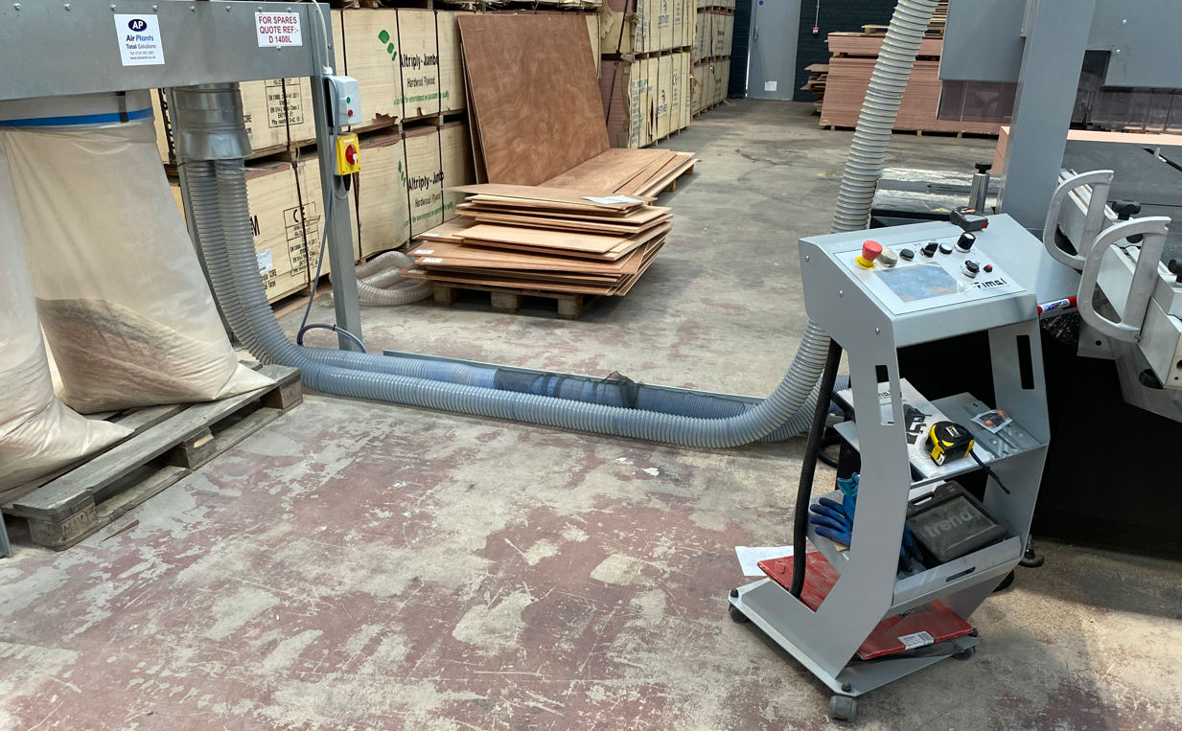
Beam saw dust extraction and collection.

